**Individual Assignment**

**Due Friday, September 20th**

Welcome to the first individual assignment in ITEC-3860! The goal from these series of individual assignments is to warm up your programming skills for the final project deliverable for your text-based adventure game. In games of this sort, the player wanders around from one location to another, picking up objects, and solving simple puzzles. The program you will create for this assignment is considerably less elaborate than the final project deliverable and it therefore limited in terms of number of rooms, items, monsters etc. Even so, you can still write a program that captures much of the spirit and flavor of the final game.

This handout contains what you need to know about the first individual deliverable along with a number of hints and strategic suggestions.

**Section 1**

**Overview of the Adventure Game**

The adventure game you will implement for this assignment—like any of the text-based adventure games that were demonstrated by your classmates in class earlier this semester—takes place in a virtual world in which you, as the player, move about from one location to another. The locations, which are traditionally called “rooms” even though they may be outside, are described to you through a written textual description that gives you a sense of the geography. You move about in the game by giving commands, most of which are simply an indication of the direction of motion. For example, you might move about as follows:

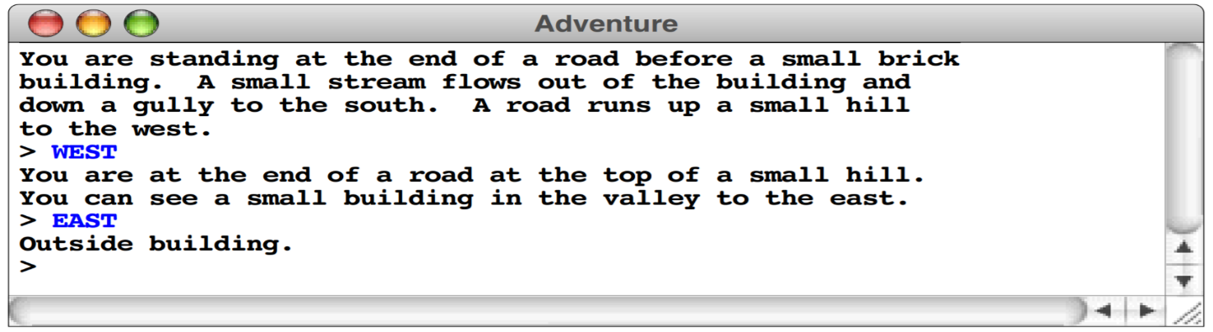

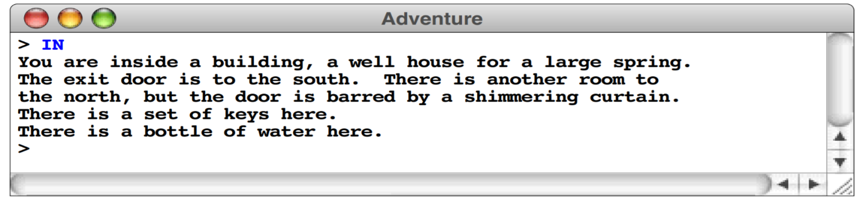

**Overview of the data files**

The adventure program you will create for this assignment and all followed up assignments is entirely data driven. Just like your final project. The program itself doesn’t know the details of the game geography, the objects that are distributed among the various rooms, or even the words used to move from place to place. All such information is supplied in the form of data files, which the program uses to control its own operation. The ultimate goal is if you run the program with different data files, the same program will guide its players through different adventure games.

For this first assignment, there must be an associated data file:

* Rooms.txt, which defines the rooms and the connections between them.

For example, the room data file could have the following information:

* A room number, which must be greater than zero
* Its name, which is a one-line string identifying the room
* Its description, which is a multiline array describing the room
* A flag indicating whether the room has been visited
* A navigation table specifying the exits and where they lead

For example, this data file is not a Java program, but is instead text file that describe the rooms and their connections.

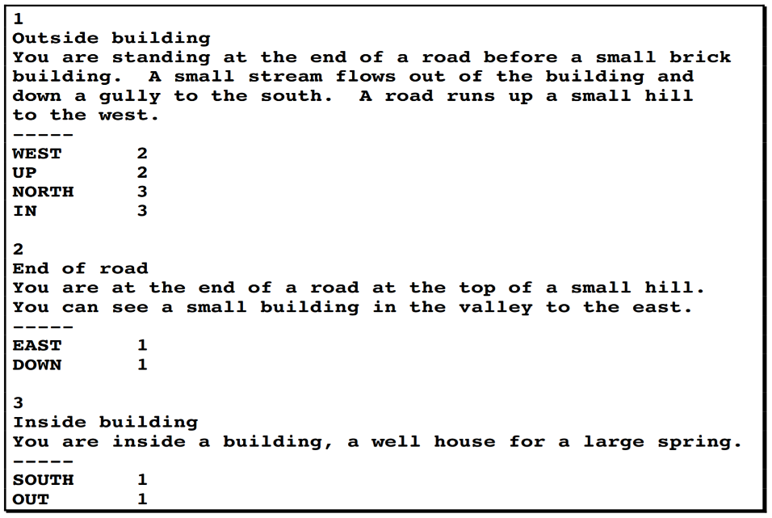

The program you will write for this assignment must:

1. Read this file into an internal data structure, which it then displayed to the user on the console to guide the player through the game.
2. Allow the player to be able to move between rooms by reading and executing navigation commands entered by the user through the console
3. Your program should be able to track visited rooms and display the message visited on the console if the player revisit a room.
4. A total of 6 rooms is enough for this assignment with a minim of three navigation commands